**CSS**

#para 1 { text-align: center; color: red; }

Selector declaration

# <- id

. <- .class

Any element can be used as a selector

Pseudo classes (link) they’re predetermined for each element (a is for links)

a:link { color: #FF0000; } /* unvisited link */

pseudo class (visited). Links with class “red” applies to this

a.red:visited

/*format first letter of all p elements*/

p::first-letter { color: #ff0000;

font-size: xx-large; }

combining pseudo elements

p::first-letter{color:#ff0000; font-size:xx-large;}  
p::first-line{color:#0000ff; font-variant:small-caps;}

First letter of the p will be red, xx-large.

The rest of the first line will be blue, small-caps.

: pseudo classes

like hover

:: pseudo elements

like first-letter

+adjacent

~sibilings

> child

float - is like through when inserting images

absolute is positioned (any element except static) relative to the nearest positioned ancestor.

**XSD**

DTD

<!ELEMENT books (book+)>

<!ELEMENT book (title, author, year, price)>

<!ELEMENT title (#PCDATA)>

<!ELEMENT author (#PCDATA)>

<!ELEMENT imageurl (#PCDATA)>

<!ELEMENT price (#PCDATA)>

<!ELEMENT publicationdate (#PCDATA)>

<!ELEMENT publisher (#PCDATA)>

<!ATTLIST book type CDATA "category">

Starts with root, and moves in

Describing each element one at a time

#PCDATA - Parsed character data (means required)

Atlist is attribute list

CDATA = not being parsed, can exist but not mandatory

**Javascript**

DOM - Document Object model

Interpreter vs compiler

Line by line. Error only found when executed

Compiler – finds glaring errors during compile time

Javascript – web browser acts as the interpreter

Type inferenced – var instead of (int, string etc very much like python)

Function name(parameters) {

}

Writing into an alert box, using window.alert().

Writing into the HTML output using document.write().

Writing into an HTML element, using innerHTML.

Writing into the browser console, using console.log().

== string

=== same object and same value

var strin30= “30”

+string30 -> turns it into a number

**Jquery** - .ready (when the web page is ready, something is run)

$(“#inputBox”) same as document.getElementById(“inputBox”)

$(“p #inputBox”)

Blurr vs focus

Focus on an object its being selected on the page

.blurr event when you leave the object. We can get the object that we just used. We can quickly validate the input

api.jquery.com

$() – shortcut to call the jquery function

$.get() – invokes the helper function of get in jquery

XPath

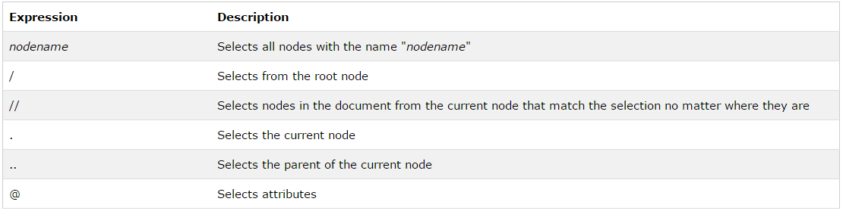

Examples –

Predicates are used to find a specific node or a node that contains a specific value.

Predicates are always embedded in square brackets.

In the table below we have listed some path expressions with predicates and the result of the expressions: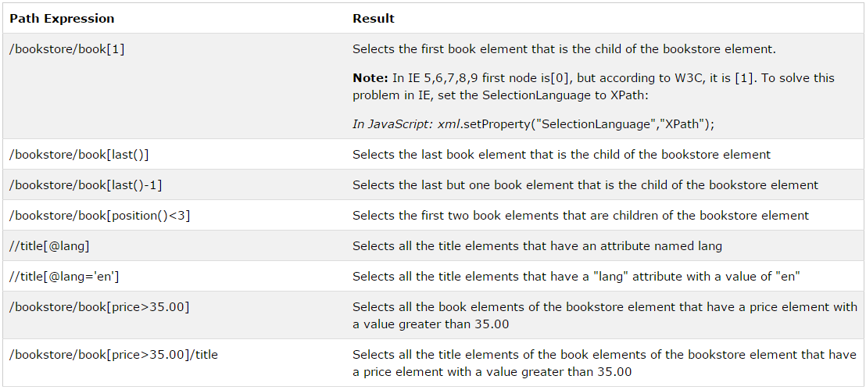

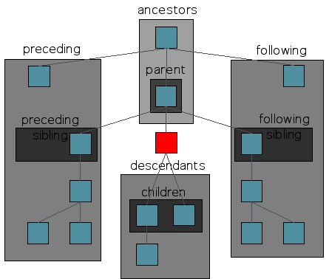

JavaScript – weakly typed language.

Var mywindow = window.open(“”, “MsgWindow”, “width=300px height=200px”);

.getelementbyid(“demo”).innerhtml =

.getelementbyclassname

Document.write

Sort()

Concat()

Join() – array to string

Push() – add to end of array

Pop() – remove last element of array

Shift – remove first element

**Polymorphism**

**overload vs overriding**

**overloading –** methods with the same name but different parameters

**overriding –** overriding another method that’s been inherited.

**CRUD** - Create, read, update and delete

**Android**

Android lifecycle (onCreate) etc

**Structure**

**Clarity of explaination**

**Technical knowledge**

**Depth of knowledge**

**Audience engagement**

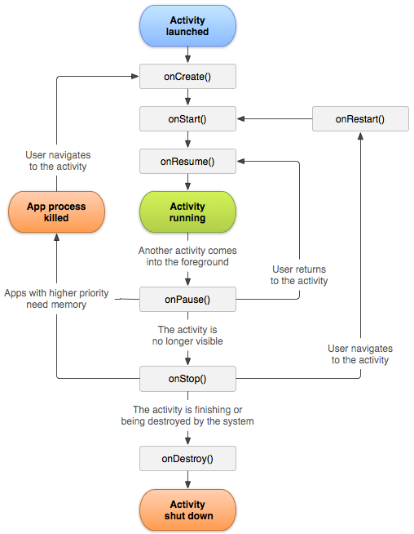

Hitting the home button will indeed call the onPause() method but because the home button makes your activity no longer visible it will then call the onStop() method (like patriot & milter mentioned).

Alternatively, you call an activity that will only partially obstruct the calling activity. So call an activity that creates a window with a view of size:

android:layout_width="100dp"

android:layout_height="100dp"

Which doesn't cover the entire screen, thus leaving the calling activity behind partially visible, thus calling only calling activity's onPause() method.

* **Network Security:** MD5, AES, (3)DES, RSA, asymmetric encryption, hashing, SQL Injection, XSS, CSRF
* **Artificial Intelligence** A*, local and graph search, CSP, mini-max, Expectimax, reinforcement learning, Bayes and Neural Net, Decision Trees

A* - performance and accuracy. Best-first search. weighted graphs. Starts to construct a tree of paths expanding one step at a time. Which one to expand on? Weights f(n) = g(n) + h (n). g(n) is actual cost, h(n) is heuristic. The estimated cost. H(n) must be admissible (meaning value of h(n) never overestimates the actual cost to get to the nearest goal node.)

Reinforcement learning –

Bayes and neural nets

Decision tree – decision analysis